Exploratory Data Analysis (CNCITY) - (the actual report starts from page 8)

**Gas Pressure Regulator 1:**

**Electricity 1: (5000 lines)**

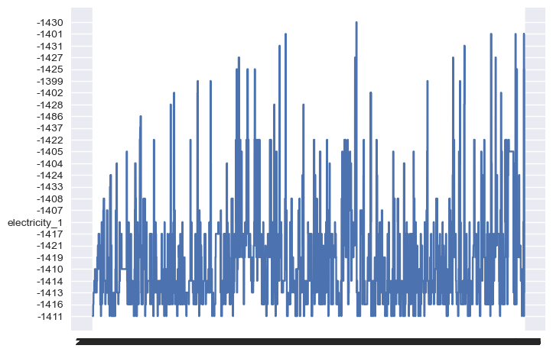

**Linear Regression: (pressure_2, is_maintenance) - epic failure**

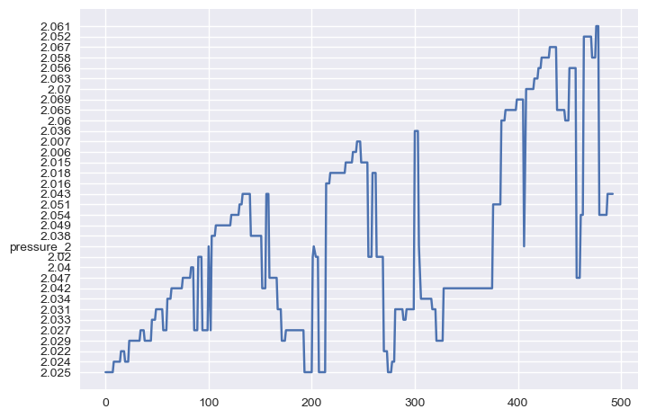

**Key takeaways from this graph:**

* **Since linear regression gives us a float between 0 and 1, logistic regression seems to be a better model when predicting is_maintenance. (is_maintenance is a binomial variable)**
* **It turns out that the ‘is_maintenance’ column is just 0’s**

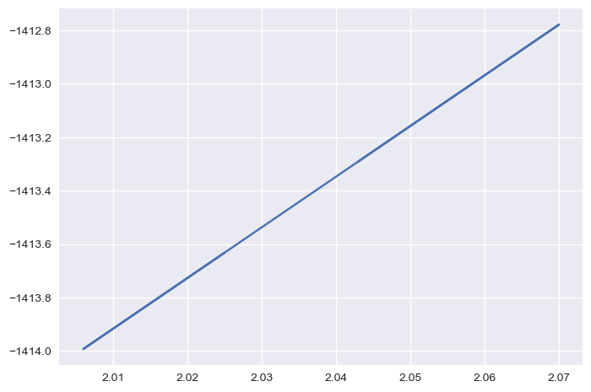

**Ran linear regression with ‘electricity_1’ and ‘pressure_2’**

* **‘Electricity_1’ and ‘pressure_2’ are positively/linearly correlated**

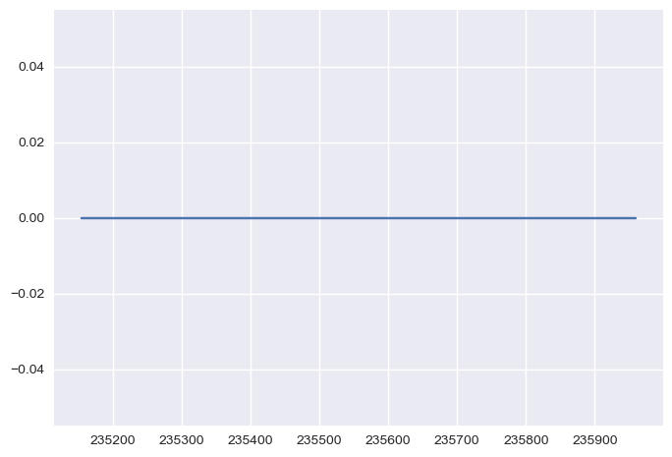

**X label: time, y label: electricity 2**

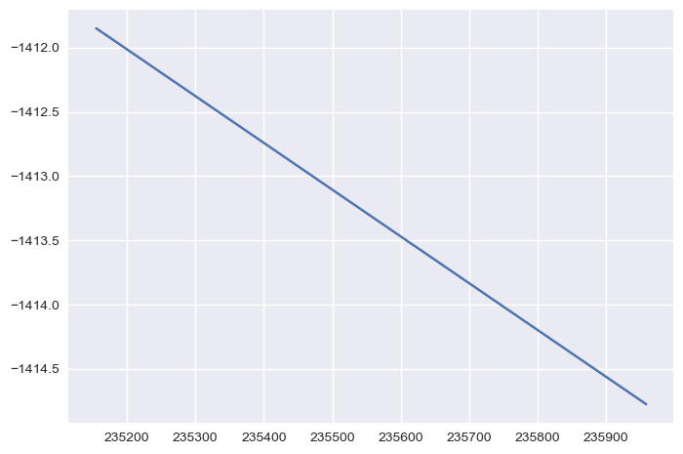

**Linear Regression: time, electricity_1**

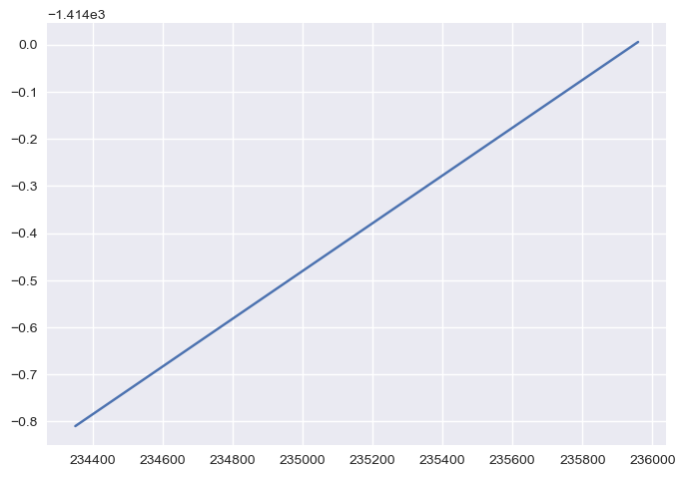

**The graph below is far more informative and intuitive.**

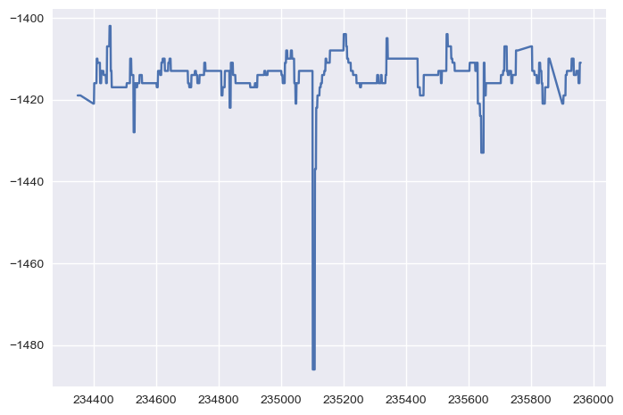

**Pressure_1_status and time**

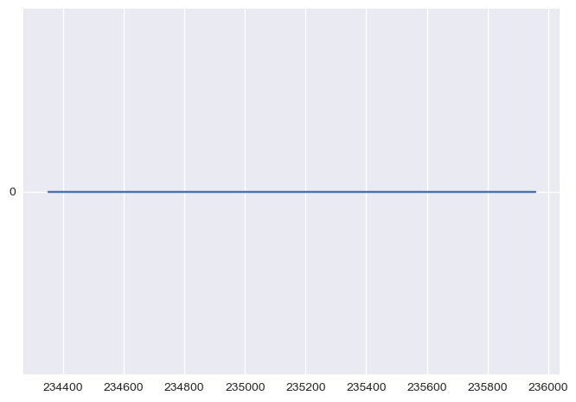

**Pressure_2:**

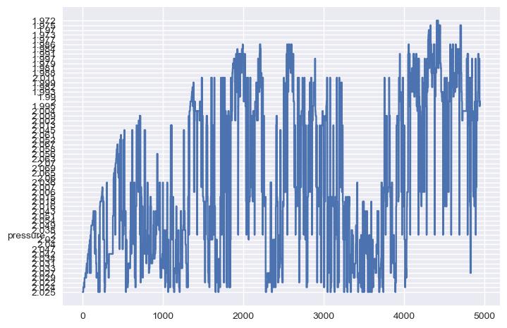

**X axis: time, Y axis: status_electricity_1**

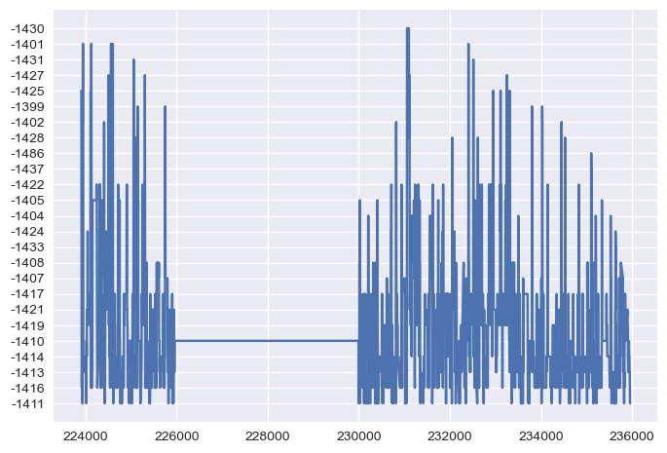

**X axis: time, Y axis: electricity_1**

[**https://www.w3schools.com/python/python_ml_knn.asp**](https://www.w3schools.com/python/python_ml_knn.asp)

**6/11/2024:**

* **Query + connection manager**
* **Table_df (5000+ lines)**
* **Stanford lecture videos**

**Gas pressure regulator (1) - EDA**

1. Visualization
   1. (graphs can be found in pages 1-7)  
      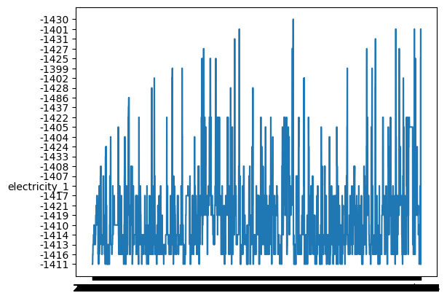
      1. Electricity 1: no seasonality, data seems to be stationary
2. Split the dataset into train and test sets
3. Linear regression and logistic regression
4. Decision trees
5. Stationarity tests

Plotted y_pred_new (used linear regression to predict the values of electricity_1 over time)

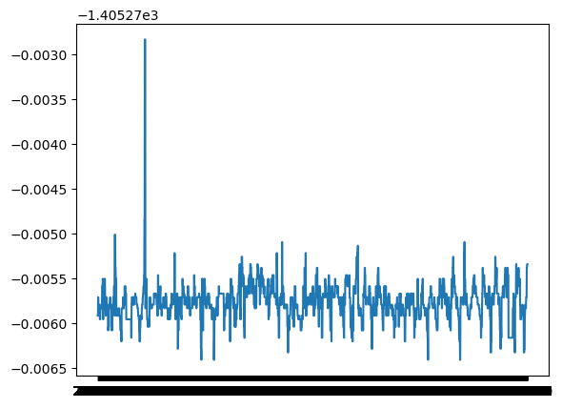

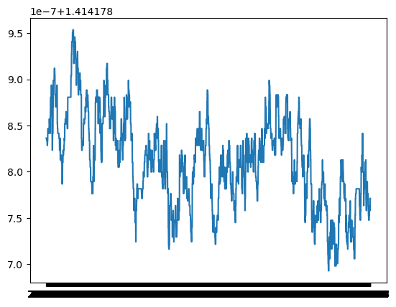

‘Pressure_2’ and ‘time’: model_pressure_2.intercept_: array([1.41417356])

Model_pressure_2.coef_: array([[2.60484877e-06]])

Linear regression plot (pressure_2 and time)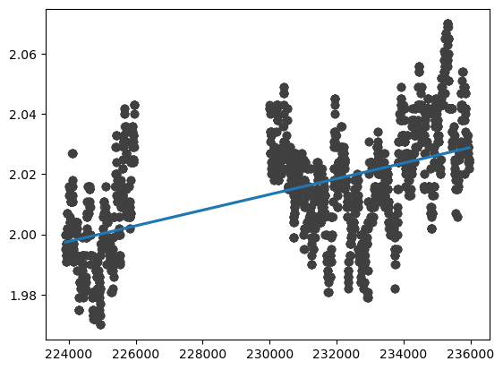

Key takeaways:

row/sec : must read at least 86,400 rows